**Lab 1: Exploring Paleoecological Data with Neotoma Explorer**

*Nicholas B. Sullivan*

14 Sept 2018

**Question 1: What is the latitude and longitude of Devil’s Lake? What is the Site ID?**

Latitude: 43.4178

Longitude: -89.73205

Site ID: 666

**Question 2**

2A: What state east of the Rockies has the southernmost location of *Picea* from 21 ka to 18 ka?

Louisiana

2B: What state east of the Rockies has the southernmost location of *Picea* from 1 ka to the present?

New York

**Question 3: Which states did Lou Maher work in?**

Wisconsin, Iowa, Colorado, New Mexico

**Question 4**

**4A: How many pollen sites and datasets are from North America**

1461 sites with 1651 dataset

**4B: What is the cost of this information?**

$30,000 × 1461 = $43,830,000

2 hr × 1461 = 2922 hrs. of work

**Question 5: Why are there so many pollen sites between Minnesota and Nova Scotia?**

I’d guess it’s a confluence of high population density and high lake density. Lakes are probably a very good pollen archive and proximity to population centers will mean it’s easy for research teams to visit.

**Question 6: Show a screen shot of the map. Does mastodon tend to live in places with spruce?**

Yes, both seem to be generally clustered in the northeastern US.

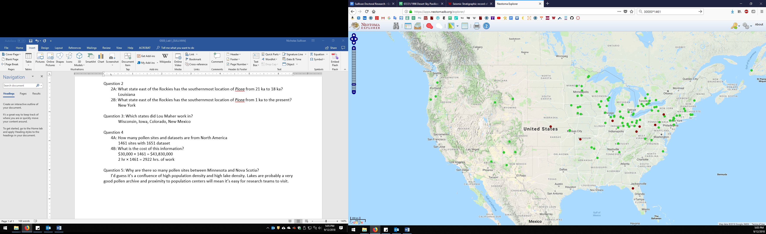

**Question 7: Plot the distribution of *Picea* over the last 21,000 years. Include a screenshot. What trends do you see?**

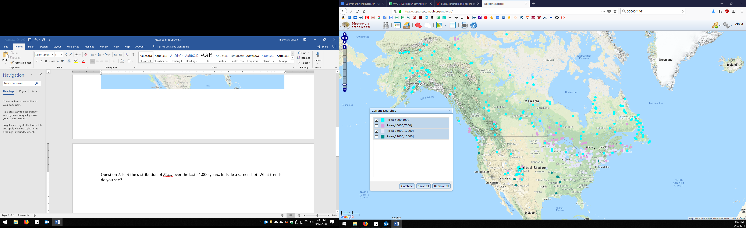

Overall the range of *Picea* has shifted northward over the past 21,000 years. This is probably linked to overall warming coincident with the end of the last glacial maximum. These range shifts are probably generational. *Picea* is a cold resistant organism. Through the late Pleistocene, early Holocene warming I’d guess *Picea* is excluded from its former habitats by competition from more warm-weather floras. Simultaneously though, northern regions that were previously too cold for it were now habitable. I suspect this took many generations of seed dispersal.

**Question 8: Take a screenshot of the plot of Devil’s Lake pollen against time:**

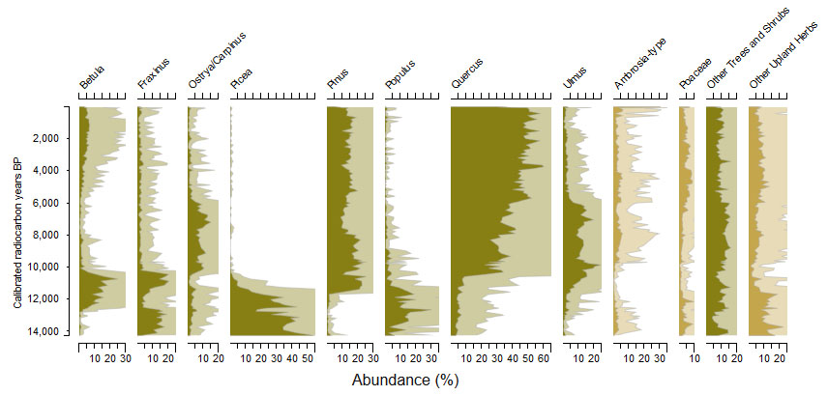

**i. What was the most abundant plant taxon at Devil’s Lake at the end of the Pleistocene?**

*Picea*

**ii. What has been the most abundant taxon through the Holocene?**

*Quercus* (Oak)

**Question 9: How many age controls are stored for Devil’s Lake?**

13

**How many of these are radiocarbon dates?**

11

**Question 10: What publications are listed for Devil’s Lake?**

Maher *et al.,* 1982

Bender *et al.,* 1980

**Question 11: Download the pollen data as a csv file. What’s the most common pollen at Depth=1cm?**

*Quercus*

**Question 12: Explore on your own**:

I have queued up palynological data from Clear Lake, a natural, spring-fed lake in Cerro Gordo County, Iowa. This is currently situated on the tall-grass prairie.

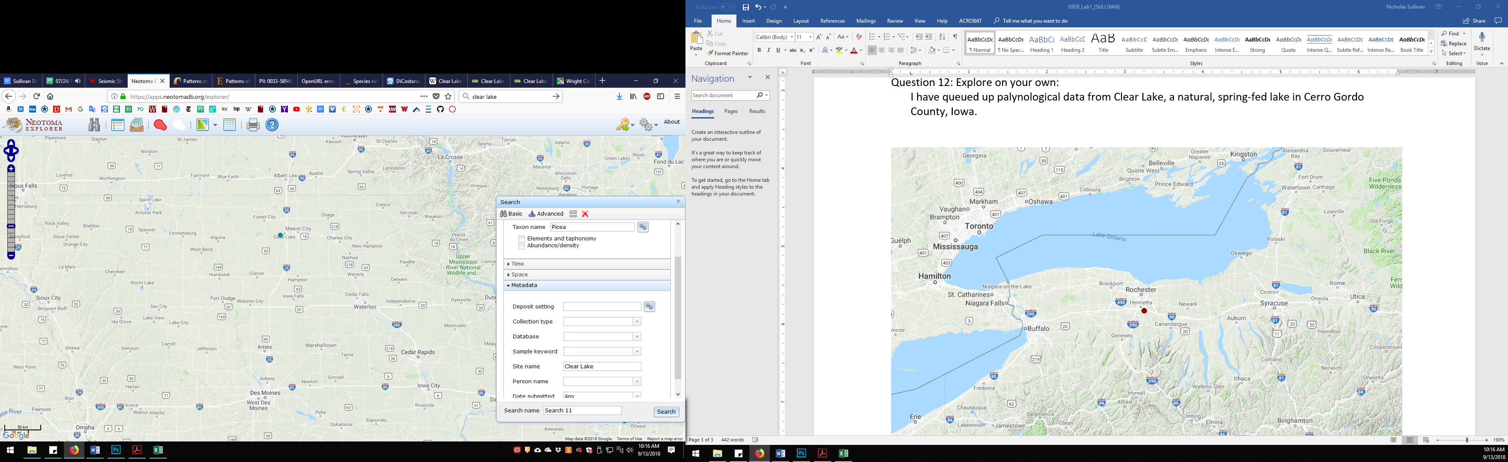

I have plotted pollen abundance data for several taxa from this locality. During the last glacial maximum, the floras in this vicinity appear to have been dominated by spruce. For a few thousand years after deglaciation, the most prominent vegetation seems to be derived from hardwood, deciduous trees like Oak and Elm. However, at around 8000 BP the abundances of these plants decrease dramatically, and the ecosystem appears to have been taken over by ragweed and grasses. This may be the result of increasing aridity in the region.

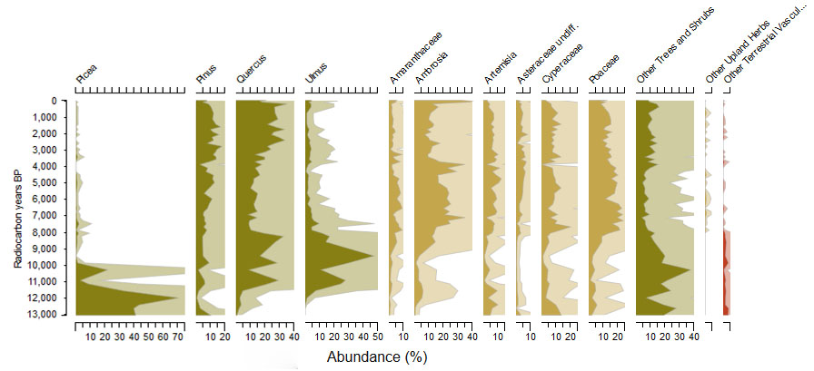

As a point of reference and contrast. I have also examined pollen data from the Devil’s Bath Tub, a small kettle lake in west-central New York, just south of Rochester in Monroe County, NY.

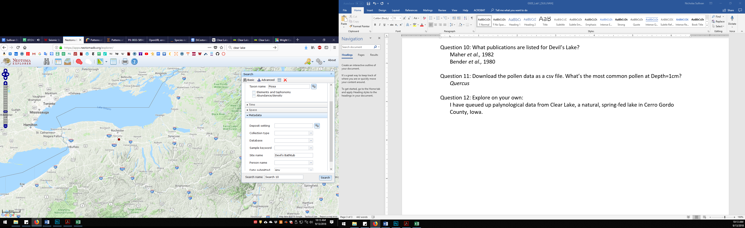

Like Iowa, this location was dominated by Spruce during the last glacial maximum >11 ka BP. This gave way to Pine for a few thousand years after deglaciation. Around 9000 BP, the environment comes to be dominated by Beech and Oak. Grasses appear to contribute an insignificant component of the flora here. This may reflect relatively high moisture and precipitation rates that continue to this day.

